The desired SQL is PostGreSQL. You can write in any SQL you want. Just mention the SQL engine.

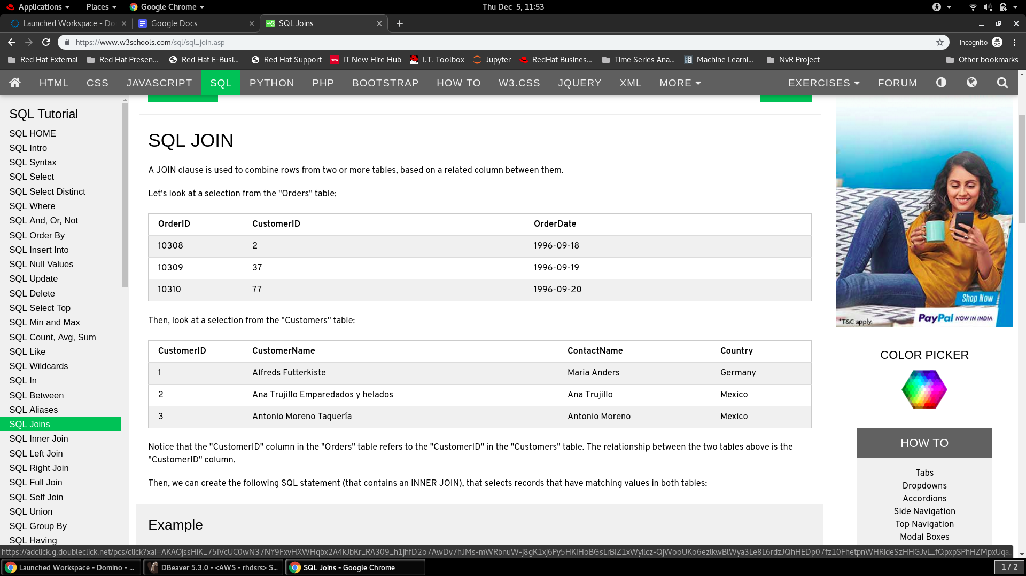

Q1. Find the Top 5 customers in each country (as per the no of orders)

Q2. For each order year find the country with max and min no of orders.

Q3. Get the Orders after the year ‘2015’ from the country of ‘Germany’

Q4. Find the difference of total no of orders from the countries ‘India’ and ‘China’ between the years ‘2010’ and ‘2020’ (both years included)

Q5. Find the average no of orders by the Customer ‘Alfreds Futterkiste’ between the months of September and December

Q1. Find the Top 5 customers in each country (as per the no of orders)

select Country, CustomerName from(

select *,

row_number() over(partition by Country order by count desc)

from(

select c.Country, c.CustomerName, count(OrderID)

from Customers c inner join Orders o

on c.CustomerID = o.CustomerID

group by c.Country, c.CustomerName

order by c.Country, count(OrderID) desc)a

)b

where row_number between 1 and 5

Q2. For each order year find the country with max and min no of orders.